**Products Table**

**1. Retrieve all columns from the product table.**

select * from products;

|  |  |  |  |
| --- | --- | --- | --- |
| ****Product ID**** | ****Product Name**** | ****Category**** | ****Unit Price (USD)**** |
| 101 | Laptop | Electronics | 500.00 |
| 102 | Smartphone | Electronics | 300.00 |
| 103 | Headphones | Electronics | 30.00 |
| 104 | Keyboard | Electronics | 20.00 |
| 105 | Mouse | Electronics | 15.00 |

**2. Retrieve the product_name and unit_price from the Products table.**

select product_name,unit_price from Products;

|  |  |
| --- | --- |
| ****Product Name**** | ****Unit Price (USD)**** |
| Laptop | 500.00 |
| Smartphone | 300.00 |
| Headphones | 30.00 |
| Keyboard | 20.00 |
| Mouse | 15.00 |

**3. Filter the Products table to show only products in the ‘Electronics’ category.**

select * from Products where category='Electronics';

|  |  |  |  |
| --- | --- | --- | --- |
| ****Product ID**** | ****Product Name**** | ****Category**** | ****Unit Price (USD)**** |
| 101 | Laptop | Electronics | 500.00 |
| 102 | Smartphone | Electronics | 300.00 |
| 103 | Headphones | Electronics | 30.00 |
| 104 | Keyboard | Electronics | 20.00 |
| 105 | Mouse | Electronics | 15.00 |

**4. Retrieve the product_id and product_name from the Products table for products with a**

**unit_price greater than $100.**

select product_id, product_name from Products where unit_price>100;

|  |  |
| --- | --- |
| ****Product ID**** | ****Product Name**** |
| 101 | Laptop |
| 102 | Smartphone |

**5. Calculate the average unit_price of products in the Products table.**

select avg(unit_price) from Products;

|  |
| --- |
| ****avg(unit_price)**** |
| 173.000000 |

**6. Retrieve product_name and unit_price from the Products table with the Highest Unit Price.**

select product_name, unit_price from Products where unit_price=(select max(unit_price) from Products) ;

|  |  |
| --- | --- |
| ****Product Name**** | ****Unit Price (USD)**** |
| Laptop | 500.00 |

**7. Retrieve the product_name and unit_price from the Products table, ordering the results by unit_price in descending order.**

select product_name , unit_price from Products order by unit_price desc;

|  |  |
| --- | --- |
| **Product Name** | **Unit Price (USD)** |
| Laptop | 500.00 |
| Smartphone | 300.00 |
| Headphones | 30.00 |
| Keyboard | 20.00 |
| Mouse | 15.00 |

**8. Retrieve the product_name and unit_price from the Products table, filtering the unit_price to show only values between $20 and $600.**

select product_name , unit_price from Products where unit_price>20 and unit_price<600;

|  |  |
| --- | --- |
| **Product Name** | **Unit Price (USD)** |
| Laptop | 500.00 |
| Smartphone | 300.00 |
| Headphones | 30.00 |

**9. Retrieve the product_name and category from the Products table, ordering the results by category in ascending order.**

select product_name , category from Products order by category asc;

|  |  |
| --- | --- |
| **Product Name** | **Category** |
| Laptop | Electronics |
| Smartphone | Electronics |
| Headphones | Electronics |
| Keyboard | Electronics |
| Mouse | Electronics |

**Sales Table**

**1. Retrieve all columns from the Sales table.**

select * from Sales;

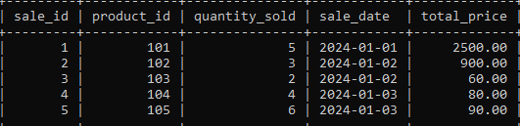

**2. Retrieve the sale_id and sale_date from the Sales table.**

select sale_id, sale_date from Sales;

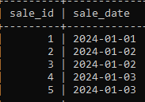

**3. Filter the Sales table to show only sales with a total_price greater than $100.**

select * from Sales where total_price>100;

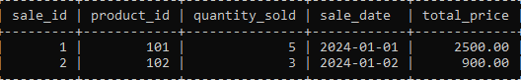

**4. Retrieve the sale_id and total_price from the Sales table for sales made on January 3, 2024.**

select sale_id,total_price from Sales where sale_date='2024-01-03';

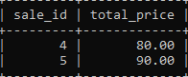

**5. Calculate the total revenue generated from all sales in the Sales table.**

select sum(total_price) as total_revenue from Sales;

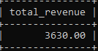

**6. Calculate the total quantity_sold from the Sales table.**

select sum(quantity_sold) as total_quantity_sold from Sales;

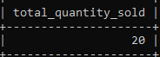

**7. Retrieve the sale_id, product_id, and total_price from the Sales table for sales with a**

**quantity_sold greater than 4.**

select sale_id,product_id,total_price from Sales where quantity_sold>4;

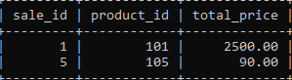

**8.  Calculate the average total_price of sales in the Sales table.**

select avg(total_price) as average_price from Sales;

